Install Zabbix server at RHEL8 and add a Linux host (ubuntu 18.04) in Zabbix server for monitoring

Installation of Zabbix server at RHEL8 is following steps

1.Disable SElinux
setenforce 0

vi /etc/selinux/config

SELINUX=disabled

Save and exit

Reboot the machine

2.Install and configure Zabbix server for RHEL 8
Confirm installation steps for your OS platform from this Zabbix installation link
https://www.zabbix.com/download?zabbix=5.0&os_distribution=red_hat_enterprise_linux&os_version=8&db=mysql&ws=apache

a. Install Zabbix repository
rpm -Uvh https://repo.zabbix.com/zabbix/5.0/rhel/8/x86_64/zabbix-release-5.0-1.el8.noarch.rpm
dnf clean all

b. Install Zabbix server, frontend, agent
dnf install -y zabbix-server-mysql zabbix-web-mysql zabbix-apache-conf zabbix-agent

c. Configure timezone
Edit file /etc/php-fpm.d/zabbix.conf, uncomment and set the right timezone for you.
vi /etc/php-fpm.d/zabbix.conf
php_value[date.timezone] = Asia/Dhaka

d. Create initial database (MariaDB)

d.1 Install MariaDB from Base Repository
yum -y install mariadb-server mariadb
systemctl start mariadb
systemctl status mariadb
systemctl enable mariadb

mysql_secure_installation

NOTE: RUNNING ALL PARTS OF THIS SCRIPT IS RECOMMENDED FOR ALL MariaDB
SERVERS IN PRODUCTION USE! PLEASE READ EACH STEP CAREFULLY!

In order to log into MariaDB to secure it, we'll need the current
password for the root user. If you've just installed MariaDB, and
you haven't set the root password yet, the password will be blank,
so you should just press enter here.

Enter current password for root (enter for none):
OK, successfully used password, moving on...

Setting the root password ensures that nobody can log into the MariaDB
root user without the proper authorisation.

Set root password? [Y/n] Y
New password:
Re-enter new password:
Password updated successfully!
Reloading privilege tables..
... Success!

By default, a MariaDB installation has an anonymous user, allowing anyone
to log into MariaDB without having to have a user account created for
them. This is intended only for testing, and to make the installation
go a bit smoother. You should remove them before moving into a
production environment.

Remove anonymous users? [Y/n] Y
... Success!

Normally, root should only be allowed to connect from 'localhost'. This
ensures that someone cannot guess at the root password from the network.

Disallow root login remotely? [Y/n] Y
... Success!

By default, MariaDB comes with a database named 'test' that anyone can
access. This is also intended only for testing, and should be removed
before moving into a production environment.

Remove test database and access to it? [Y/n] Y
- Dropping test database...
... Success!
- Removing privileges on test database...
... Success!

Reloading the privilege tables will ensure that all changes made so far
will take effect immediately.

Reload privilege tables now? [Y/n] Y
... Success!

Cleaning up...

All done! If you've completed all of the above steps, your MariaDB
installation should now be secure.

Thanks for using MariaDB!
Login into MariaDB server.
mysql -u root -ppassword

d.2 Create Database
Start the MariaDB service.
systemctl start mariadb
mysql -u root -ppassword
Create a database with the following details.
DBName: zabbixdb
DBUser: zabbixuser
DBPassword: password
mysql -u root -ppassword
MariaDB [(none)]> create database zabbixdb character set utf8 collate utf8_bin;
MariaDB [(none)]> SHOW DATABASES;

MariaDB [(none)]> CREATE USER zabbixuser IDENTIFIED BY 'password';
MariaDB [(none)]> SELECT User FROM mysql.user;
MariaDB [(none)]> GRANT ALL PRIVILEGES ON zabbixdb.* TO zabbixuser;
MariaDB [(none)]> FLUSH PRIVILEGES;
MariaDB [(none)]> SHOW GRANTS FOR zabbixuser;
MariaDB [(none)]> quit;
On Zabbix server host import initial schema and data. You will be prompted to enter your newly created password.

zcat /usr/share/doc/zabbix-server-mysql*/create.sql.gz | mysql -uzabbixuser -p zabbixdb
Enter password:

d.3 Update Database Configuration
Edit the zabbix_server.conf file to set the database details.
vi /etc/zabbix/zabbix_server.conf
Make sure you set as follows.
DBHost=localhost
DBName=zabbixdb
DBUser=zabbixuser
DBPassword=password

e. Start Zabbix server and agent processes
systemctl restart zabbix-server zabbix-agent httpd php-fpm
systemctl enable zabbix-server zabbix-agent httpd php-fpm

3.Setup Zabbix via Web Installer
Open up your web browser and point it to the following URL.
http://your-ip-add-ress/zabbix/
Follow the below steps to complete the Zabbix installation.
For both versions of Zabbix, Zabbix installation wizard instructions are the same.
Click Next Step on Zabbix welcome page.
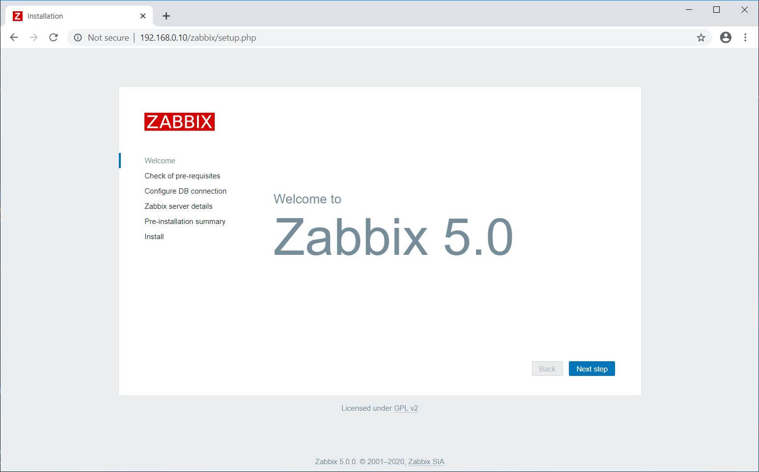Zabbix 5.0 Welcome Screen
This step verifies all the pre-requisites are met for Zabbix Installation. If there are any issues, those need to be fixed. Click on the Next Step.
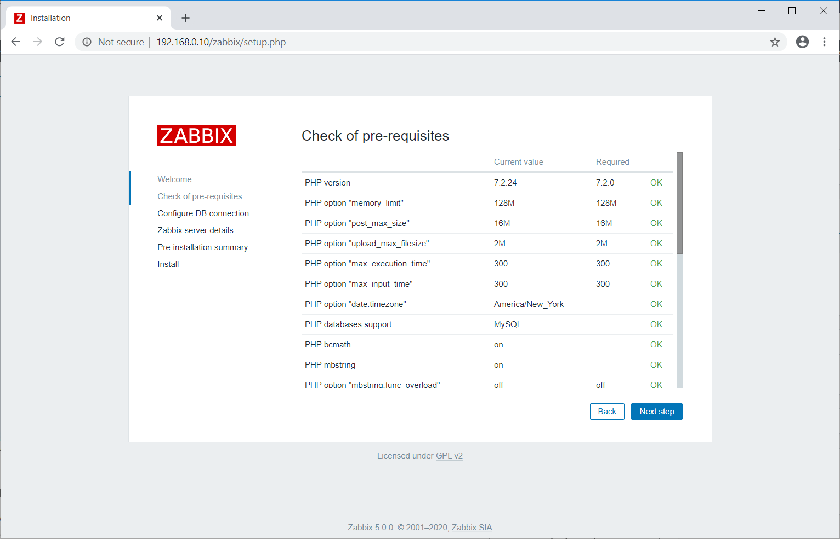Zabbix Installation Prechecks
Enter the Zabbix database name, DB user, and password. Click the Next Step.
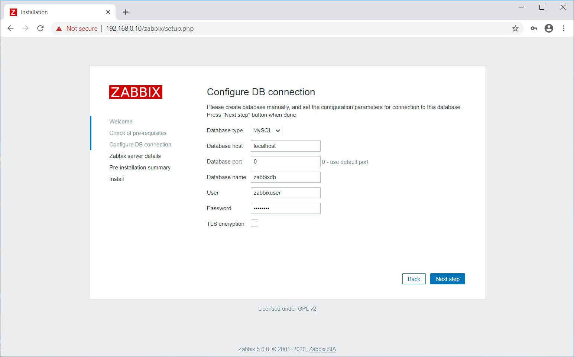Database Configuration
Mention the Zabbix server details, port number, and the name for Zabbix installation and then click the Next step.
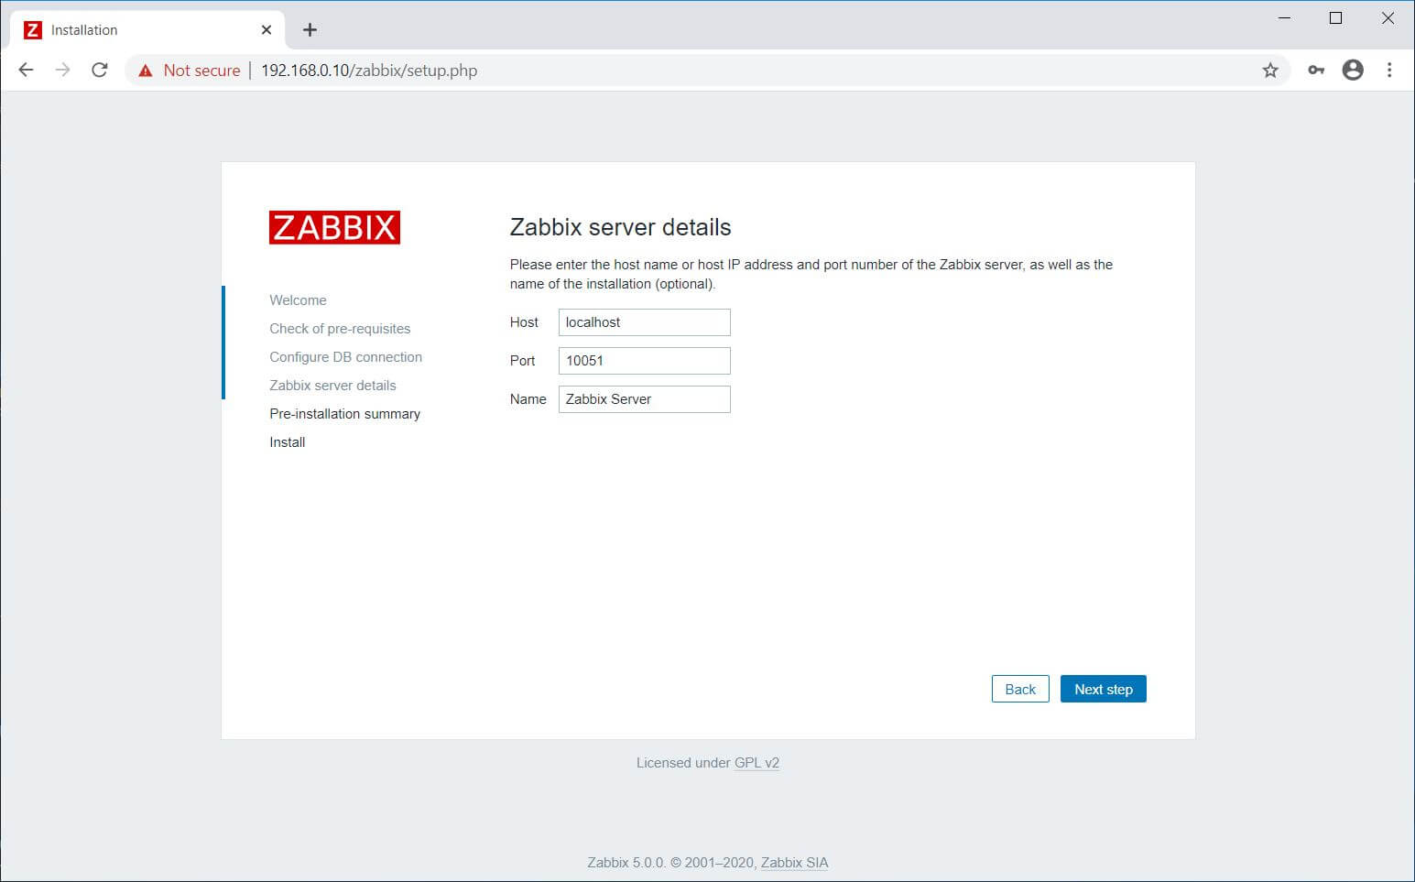Zabbix Server Details
You will get a pre-installation summary like below. Click the Next step.
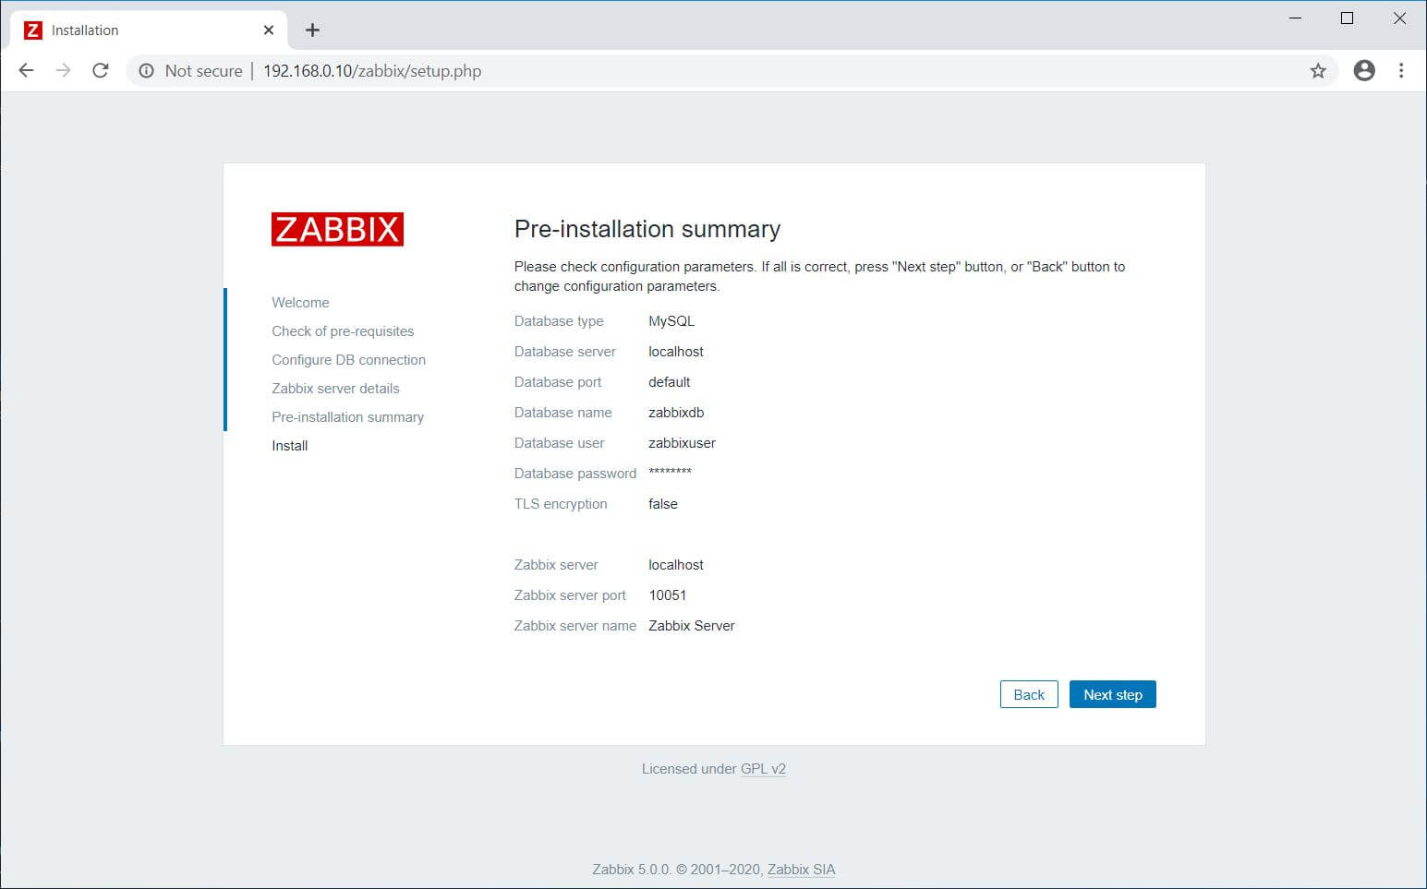Zabbix Pre-installation Summary
Now, you have completed the installation of Zabbix. Click the Finish.
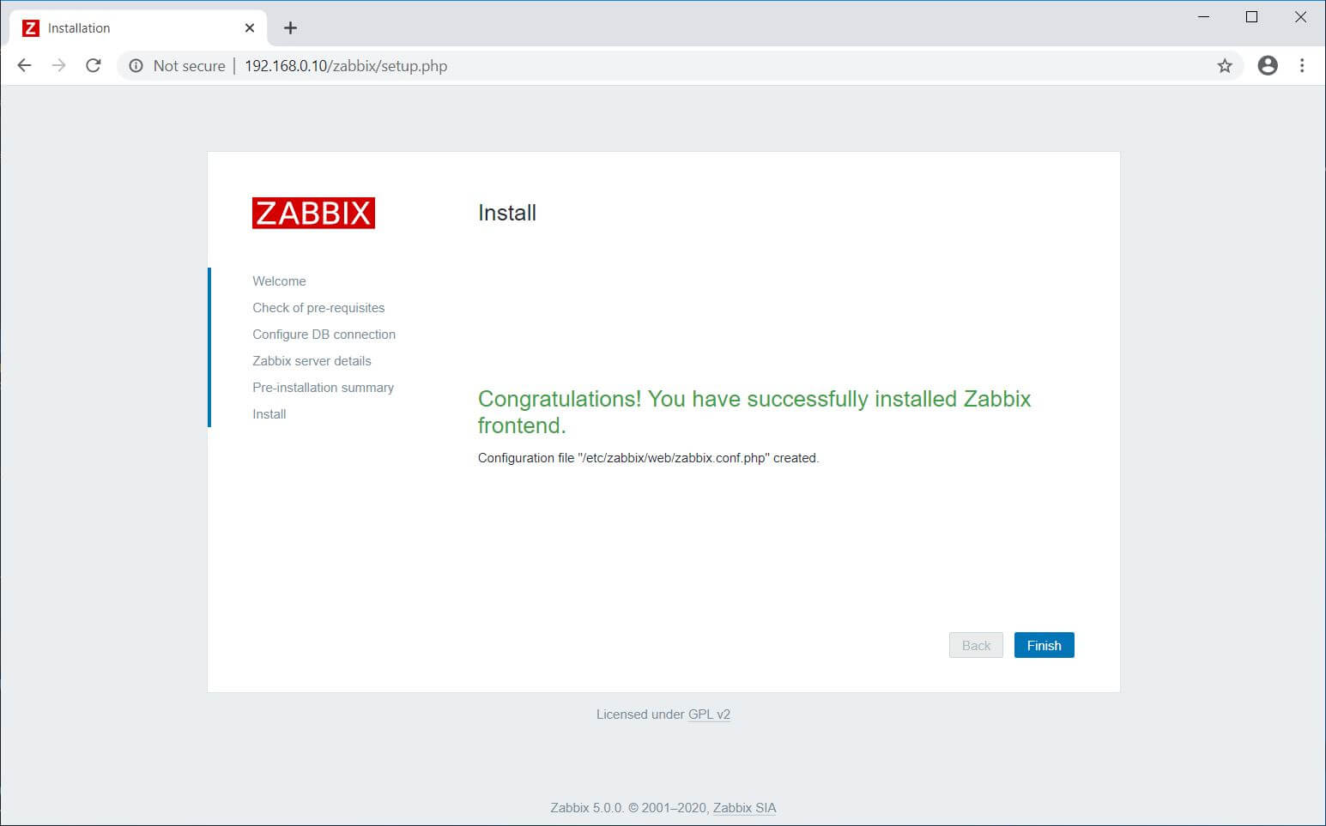Zabbix Installation Completed
Once after you clicked on Finish, the installer will redirect you to the Zabbix web console.

4.Access Zabbix Dashboard
Log in with the Zabbix default username and password.
Username: Admin
ADVERTISEMENT
Password: zabbix
Username is case sensitive.
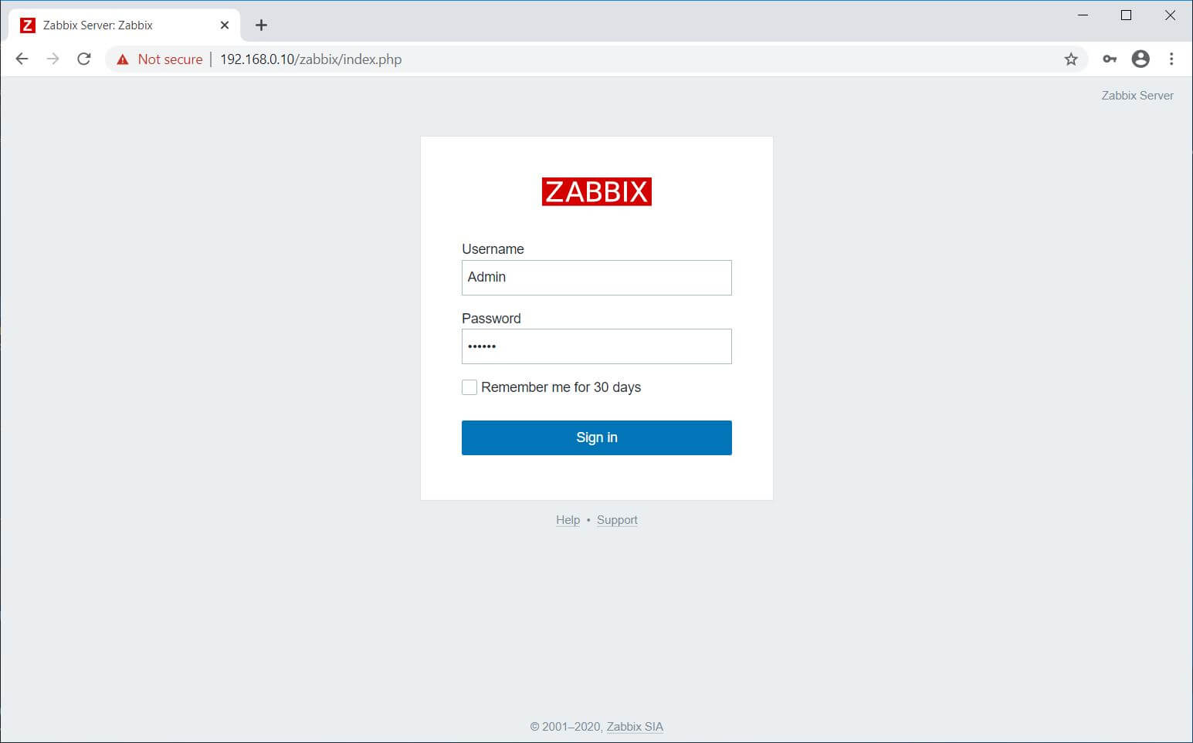Zabbix Login Page
Zabbix Dashboard:
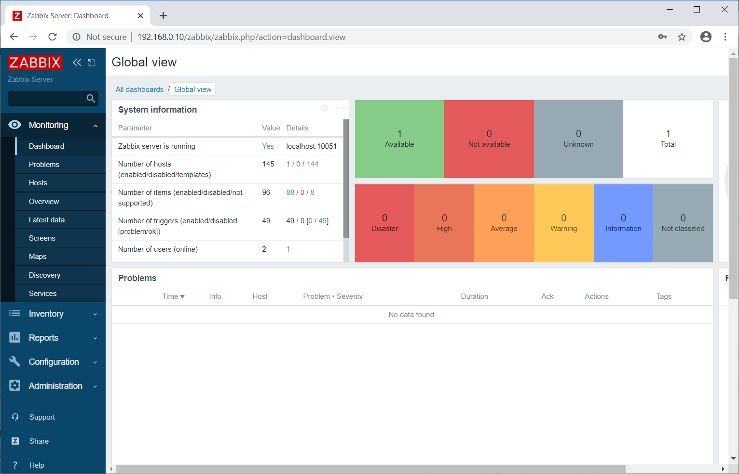Zabbix 5.0 Dashboard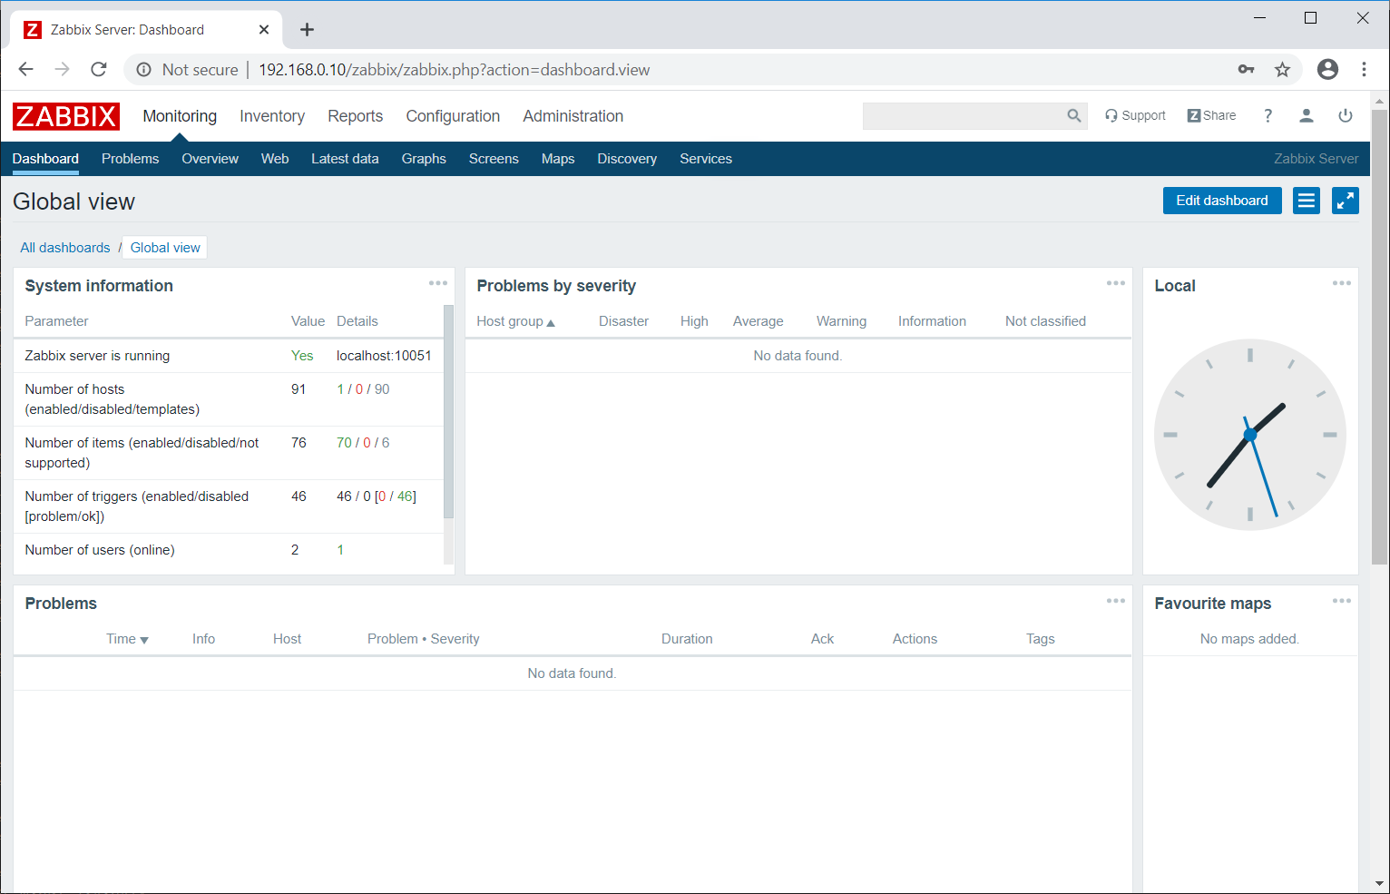Zabbix 4.0 Dashboard

6.Add Linux Host (ubuntu 18.04) in Zabbix Server for Monitoring is following steps

Step 1) Adding the Zabbix repository and Installing Zabbix agent
For Ubuntu 18.04, execute the commands below to add the repository

wget https://repo.zabbix.com/zabbix/4.0/ubuntu/pool/main/z/zabbix-release/zabbix-release_4.0-3+bionic_all.deb
sudo dpkg -i zabbix-release_4.0-3+bionic_all.deb
sudo apt-get update
sudo apt-get install zabbix-agent

Step 2) Configure Zabbix agent
With the successful installation of the Zabbix agent, we need to make a couple of tweaks for the remote system to communicate with the Zabbix server. We are going to make a few adjustments in the configuration file which is /etc/zabbix/zabbix_agentd.conf
In the file locate the Server and hostname attributes and set them to correspond to the server’s parameters. In our case, we have:
vi /etc/zabbix/zabbix_agentd.conf
Server=10.128.0.10
hostname=ubuntu20-04
Once done, save & exit the configuration file.
Also, ensure that you can reach the Zabbix server by pinging its IP address and hostname.
For the changes to come into effect, restart the Zabbix-agent as shown:
$ sudo systemctl restart zabbix-agent
To ensure it is running, check its status using the command:
$ sudo systemctl status zabbix-agent

Step 3) Allow port 10050 at security group/firewall at both zabbix server and zabbix-agent side

Check netstat status at agent side
netstat -antp | grep 10050
tcp 0 0 0.0.0.0:10050 0.0.0.0:* LISTEN 14509/zabbix_agentd
tcp6 0 0 :::10050 :::* LISTEN 14509/zabbix_agentd

Step 4) Adding or Registering Remote Linux Host in Zabbix Server
Login to your Zabbix Server portal using admin user’s credentials .To add a host on the Zabbix server, click on Configuration –> Hosts.
On the far top- right end, click on the ‘Create host’ button
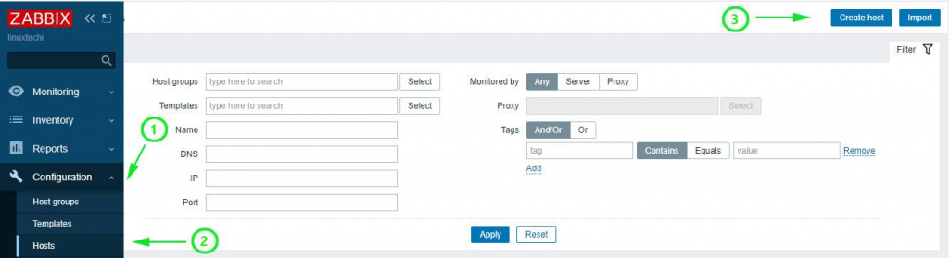
On the page that appears, fill out the remote Linux’s details as listed:
- Hostname
- Visible name
- IP address
- Description
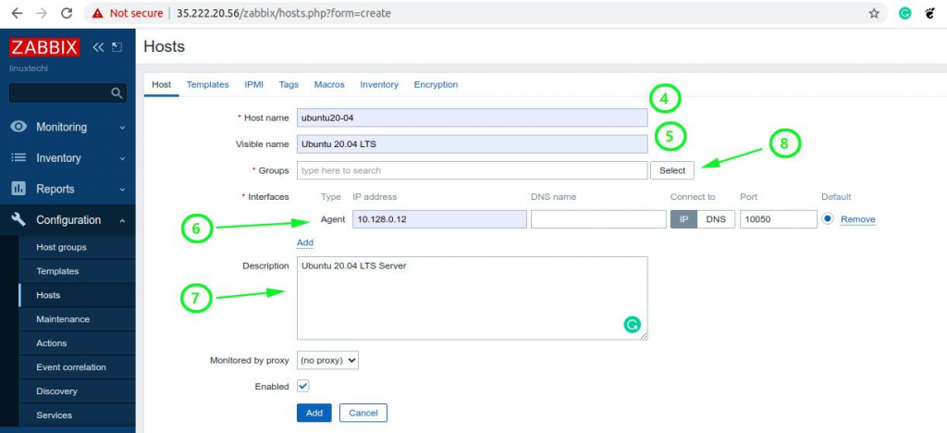
Next, click on the ‘select’ button next to the ‘Groups’ text field. On the ‘Host groups’ list, click on ‘Linux servers’ and then click ‘Select’.
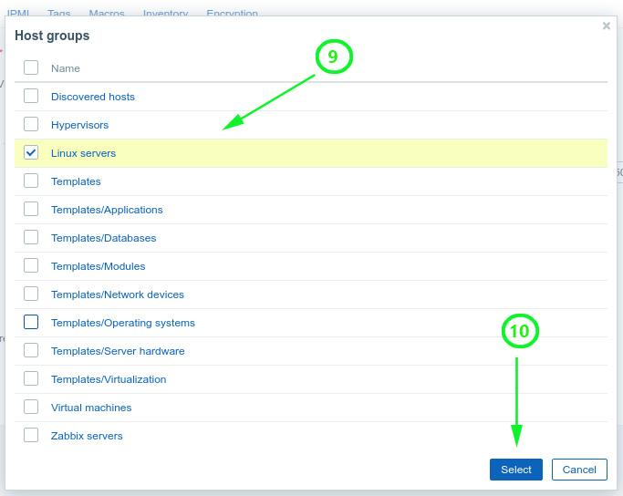
As you can see, the group has been added.
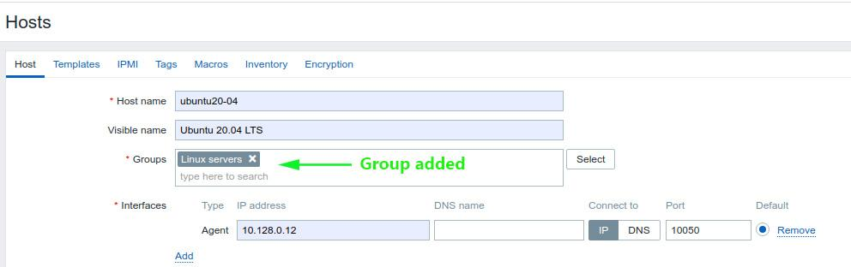We also need to add a template for our server. So, click on the ‘Templates’ menu option.
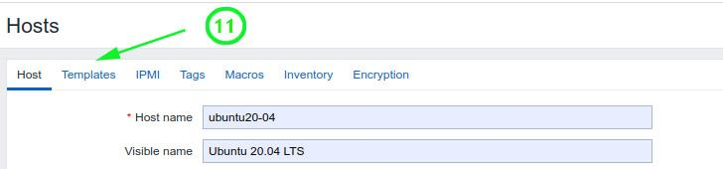

On the ‘Templates’ list that appears, click on ‘Template OS Linux by Zabbix agent’ and hit the ‘Select’ button.
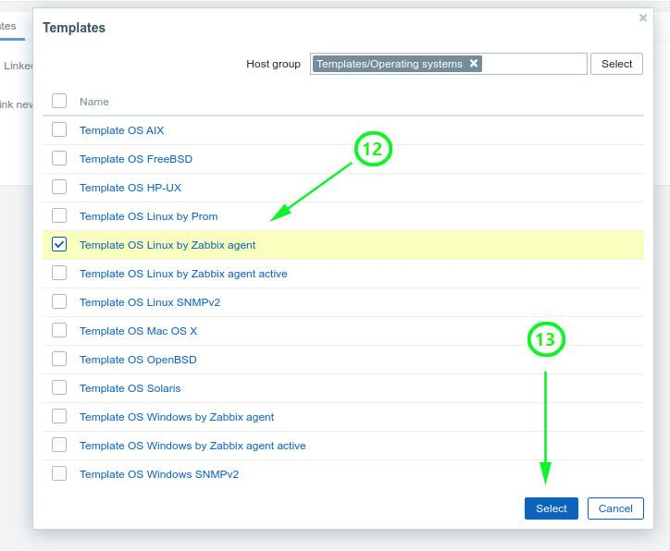

This takes you back to the home screen and there you can see that your new host system has been added.

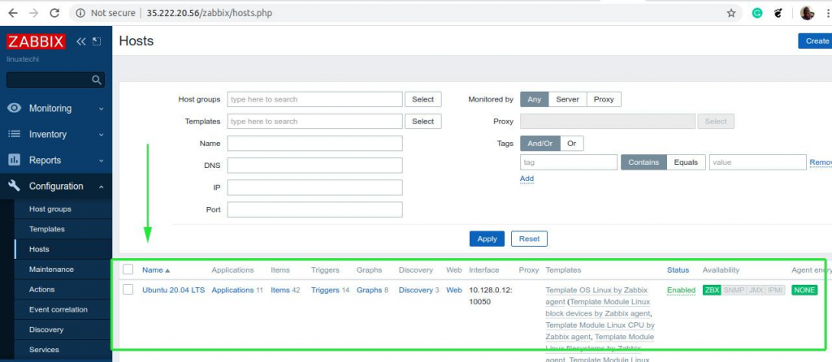

Graphing statistics of the remote hosts
o represent system metrics in a graphical form, click on ‘Monitoring’ –> ‘Hosts’
Next, click on the host you want to graph and select the ‘graph’ option from the pull-up menu.
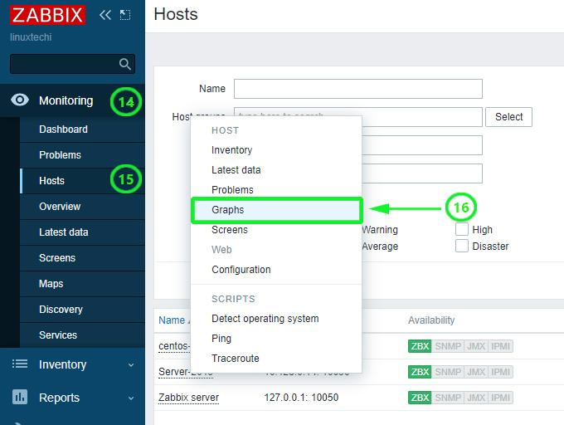
Zabbix server will begin generating various graphs representing various system metrics such as Processes, CPU load, and network traffic statistics to mention a few.

Scroll down to view other graphs displaying various metrics as shown below.

